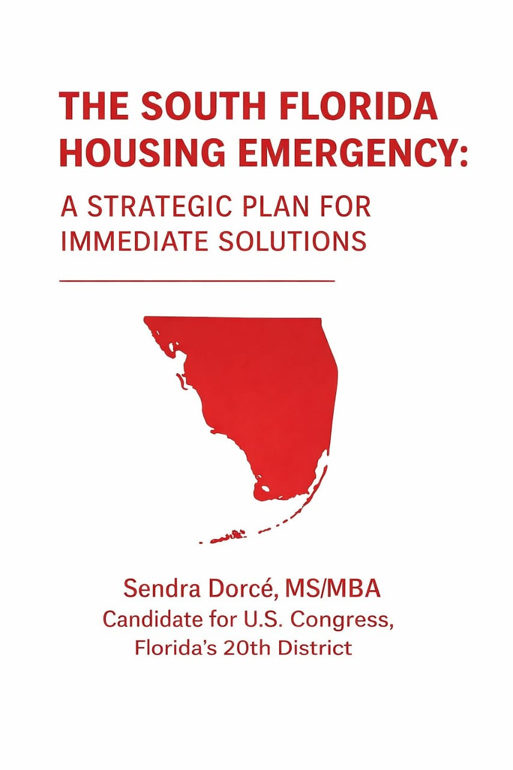

I. EXECUTIVE SUMMARY
_______________________________________________________
South Florida is facing one of the most severe housing crises in the nation. Broward and Palm Beach counties are now among the most rent-burdened communities in America. Families are struggling to stay afloat, essential workers are being pushed farther away from their jobs, and seniors and disabled residents living on fixed incomes are being priced out of the homes they spent decades building.
This white paper presents a practical and compassionate blueprint to reverse these trends by combining strong federal leadership, effective local execution, and market-aligned reforms modeled after successful strategies implemented in Port St. Lucie.
A central pillar of this platform is the elimination of property taxes for seniors aged 65 and older and for disabled residents on fixed incomes. This proposal directly strengthens housing stability for thousands of vulnerable residents and delivers immediate, meaningful relief from rising cost-of-living pressures.
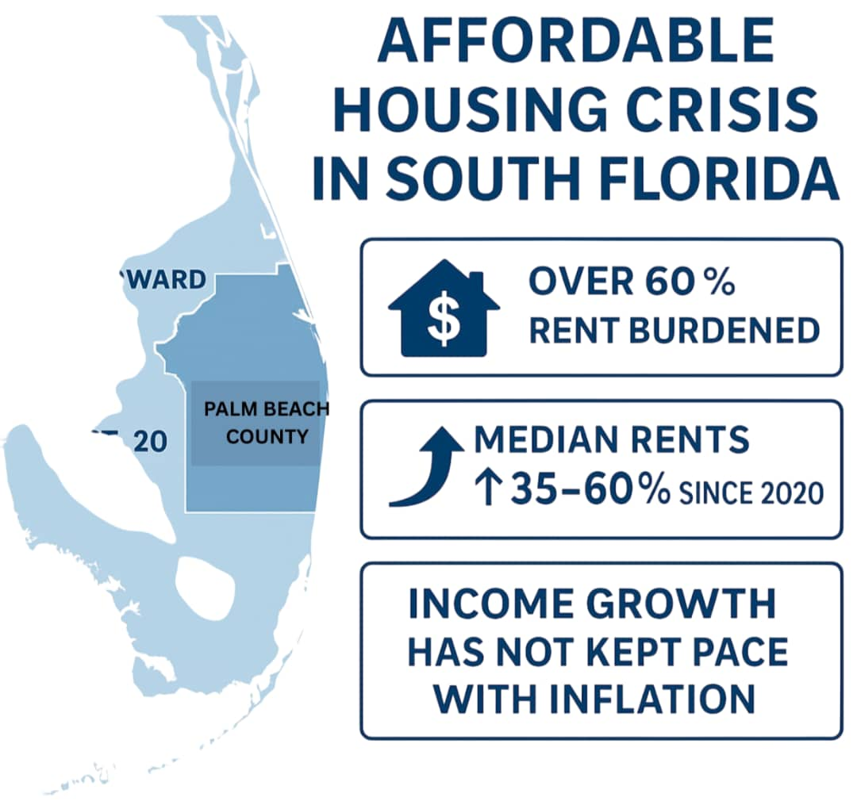

II. THE AFFORDABLE HOUSING CRISIS IN SOUTH FLORIDA
___________________________________________________________
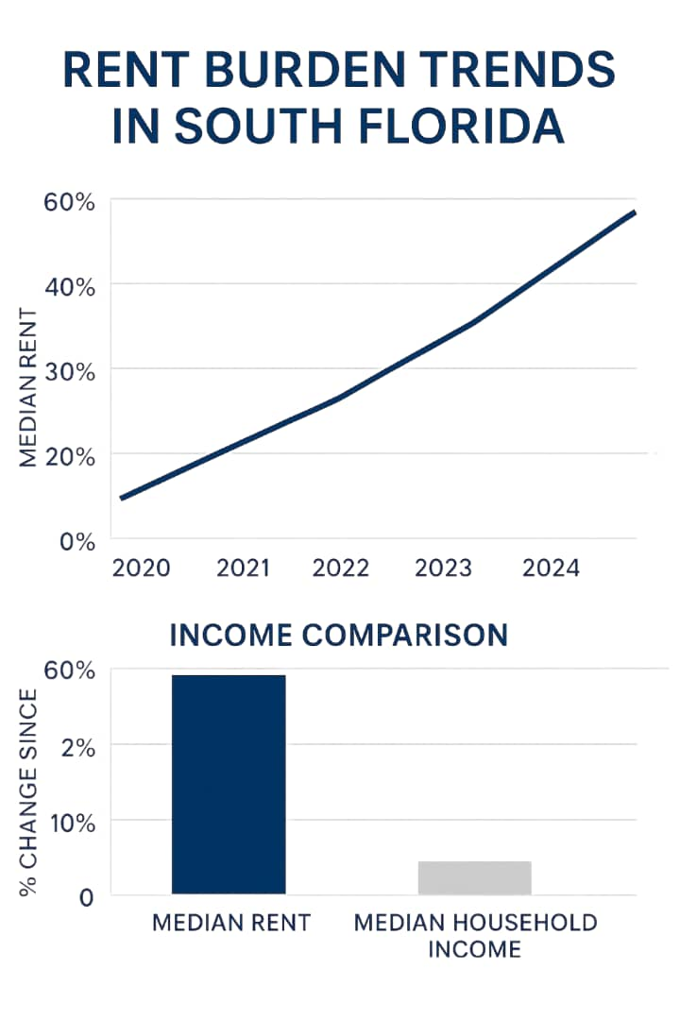

1. Highest Rent Burden in the Nation
South Florida consistently ranks in the top three most rent-burdened regions in the United States.
- Over 60% of renters spend more than 30% of income on housing
- Median rents have increased 35–60% since 2020
- Income growth has not kept pace with inflation

2. Vanishing Workforce Housing
Nurses, teachers, police officers, hospitality workers, and city employees are being priced out of the communities they serve. This is directly eroding:
- Public safety • Educational stability • Local economic productivity

3. Seniors and Disabled Residents Are Facing Displacement
South Florida has one of the largest aging populations in the U.S., and District 20 contains tens of thousands of seniors on Social Security and disability income.
But fixed incomes have not increased at the same rate as:

This population is experiencing rising homelessness at alarming rates.

III. STRUCTURAL DRIVERS OF THE CRISIS
___________________________________________________________

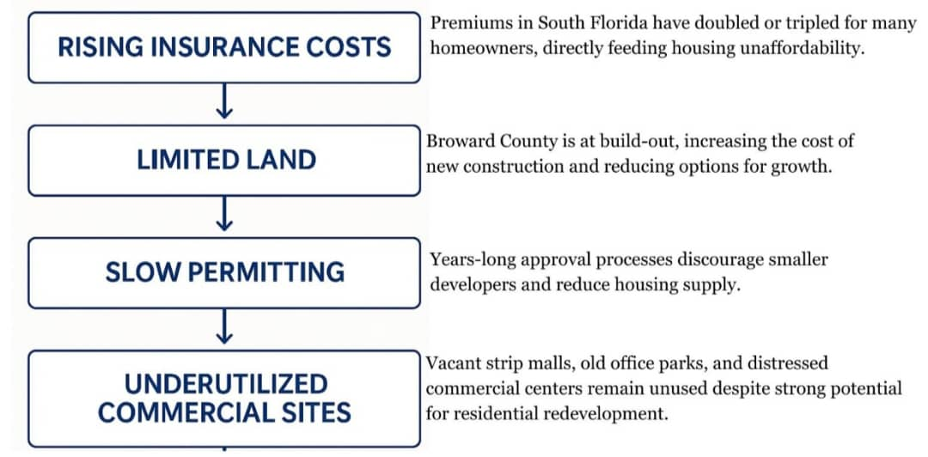
Vacant strip malls, old office parks, and distressed commercial centers remain unused despite strong potential for residential redevelopment.

IV. PORT ST. LUCIE: A PROVEN MODEL FOR SOUTH FLORIDA
____________________________________________________________

Port St. Lucie successfully expanded its attainable housing supply using three primary strategies:
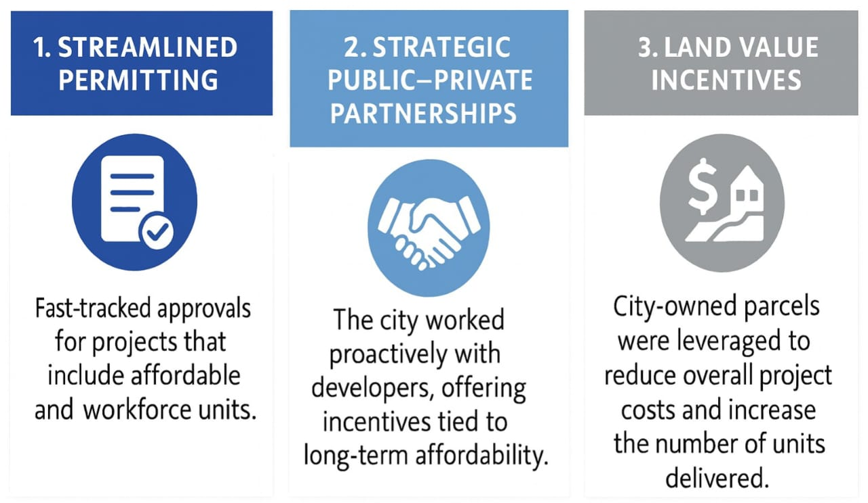
This model demonstrates that local governments can expand supply without raising taxes—an approach South Florida urgently needs.

V. POLICY SOLUTIONS FOR DISTRICT 20 - Key Proposal by Sendra Dorcé
__________________________________________________________
This platform integrates local best practices, federal tools, and new economic relief measures.
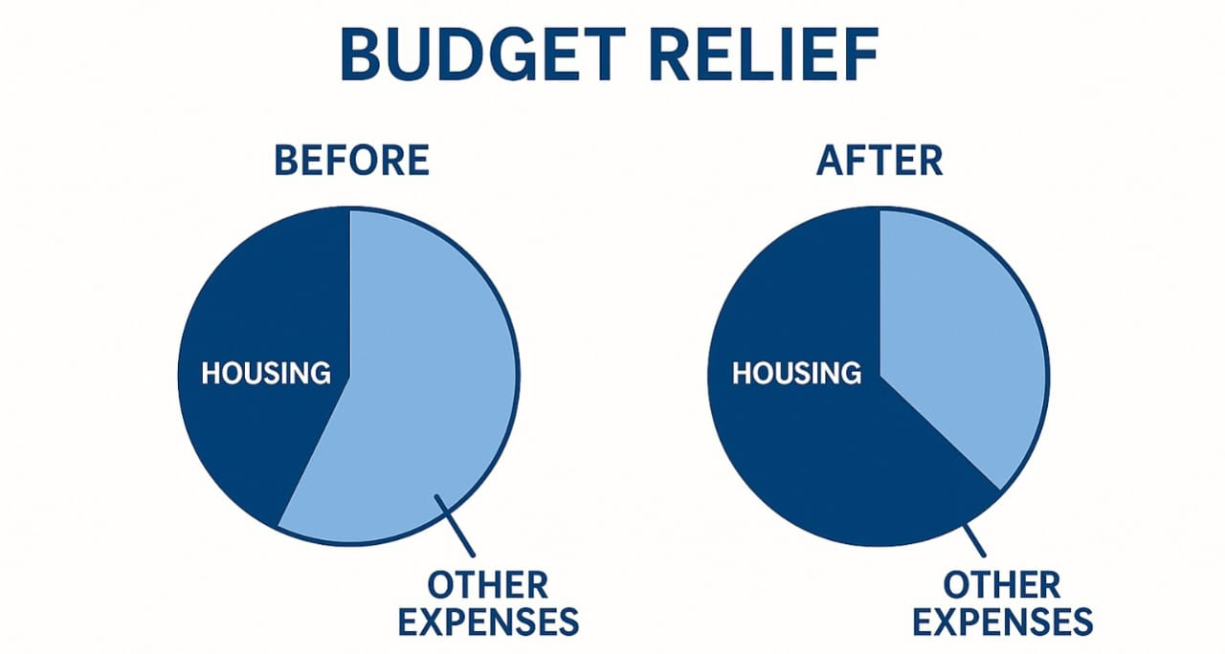
1. Eliminate Property Taxes for Seniors 65+ and Disabled Residents on Fixed Incomes
- Flagship Proposal
Goal: Give vulnerable residents immediate financial relief and support aging-in-place.
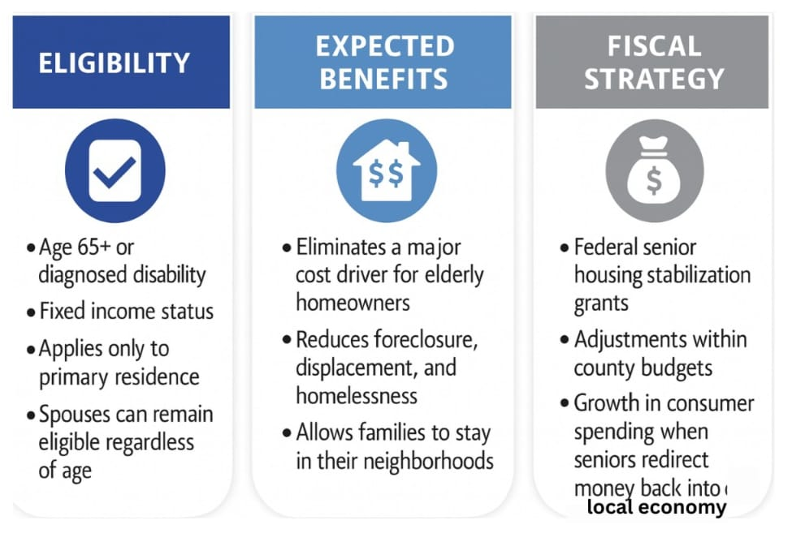
This proposal becomes a defining cost-of-living relief tool for District 20.

2. Cap Extreme Insurance Premium Hikes
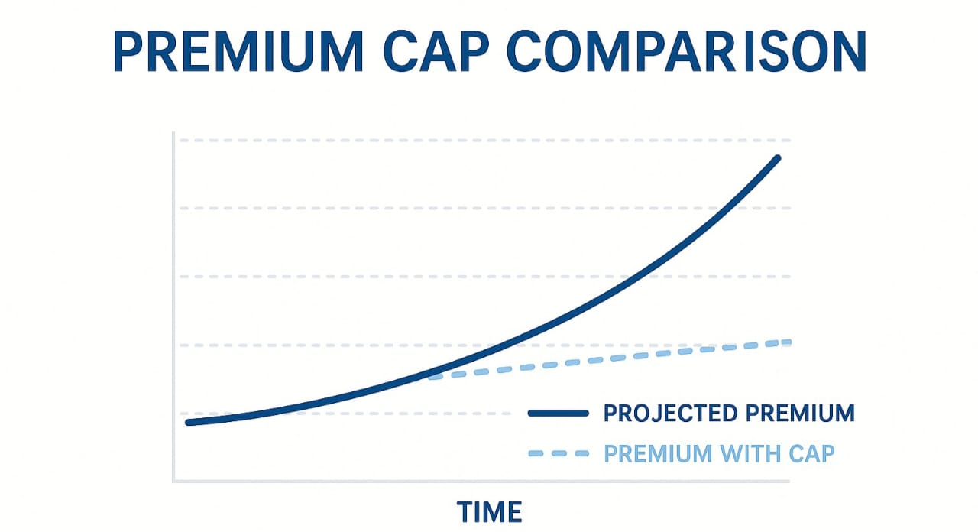
Housing affordability in Florida cannot improve without insurance reform. Federal oversight should require insurers to justify increases and prohibit steep year-over-year hikes. Federal reinsurance support can stabilize the market and reduce pressure on homeowners and renters.

3. Expand Homeownership Opportunities for Working Families
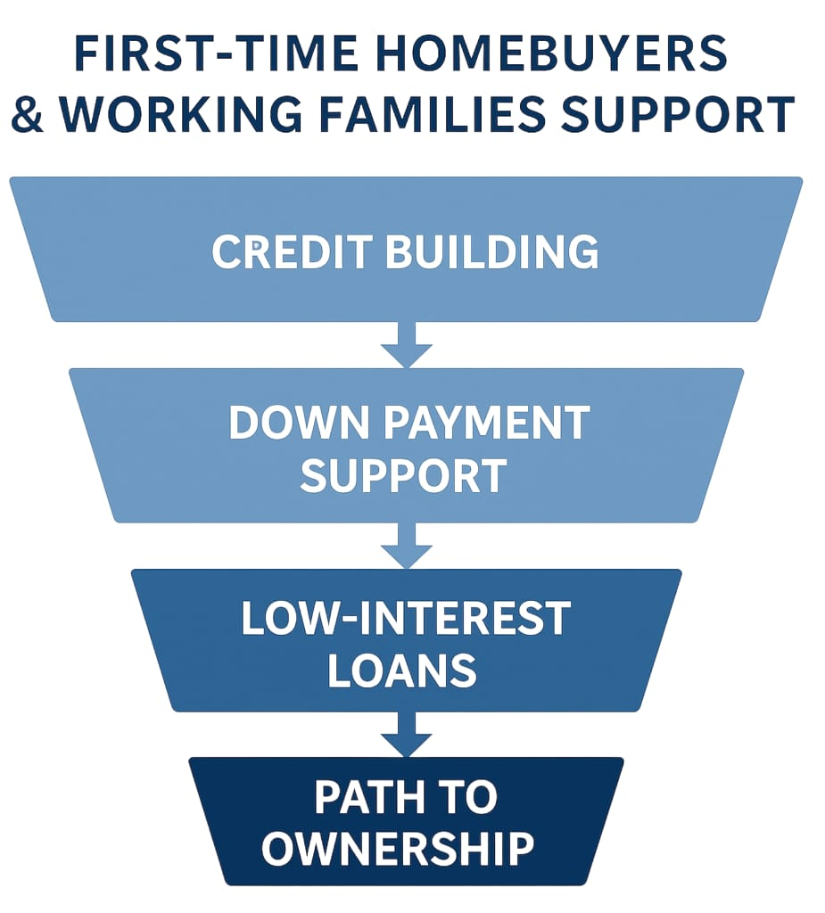
Access to homeownership is expanded through down-payment assistance, credit-building and financial literacy programs, and low-interest federally backed loans that lower barriers for working families.
Clear pathways are also created for Section 8 voucher recipients to transition from renting into stable ownership. Together, these tools strengthen housing security and help keep generational wealth rooted within District 20 communities.

4. Fast-Track Workforce and Mixed-Income Housing
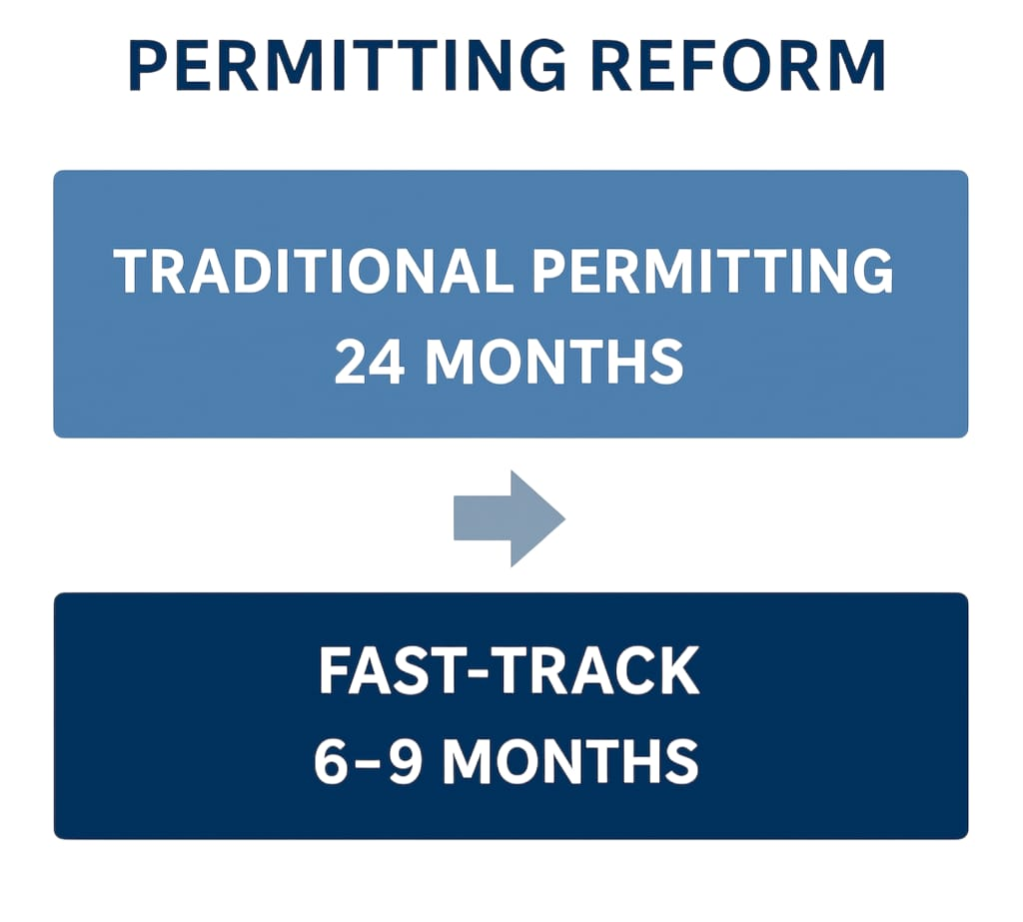
Accelerate the permitting timeline for projects that include affordable units, are near transportation corridors, or involve adaptive reuse. Reducing approvals from 24 months to 6–9 months increases supply and encourages mid-sized developers to participate.
5. Convert Vacant Commercial Property into Housing
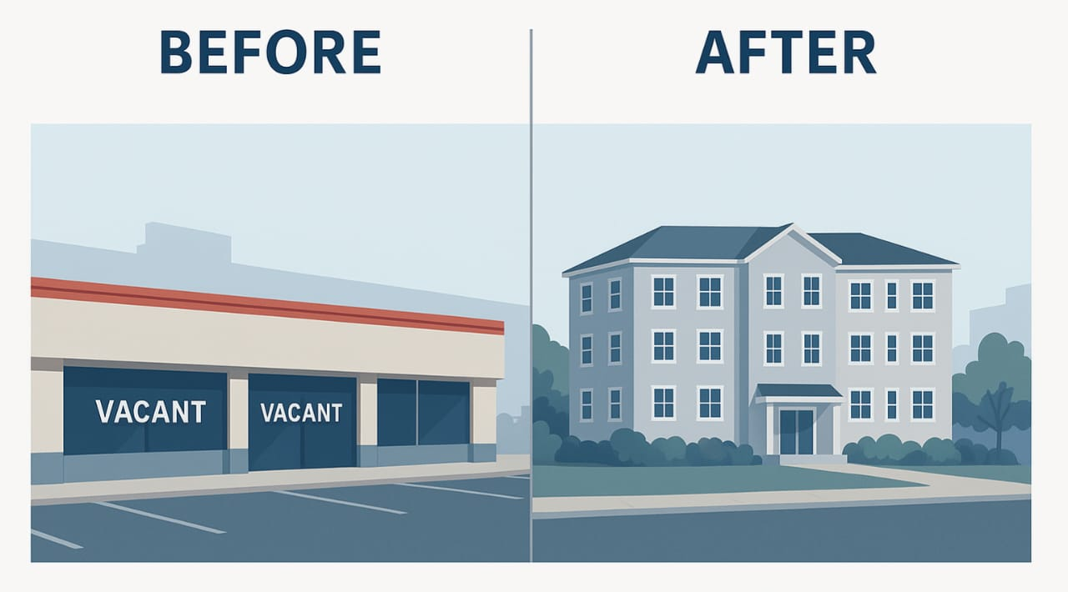
Create new housing without new land. Eligible conversions include:
- Empty strip malls into senior housing
- Old office parks into mixed-income communities
- Distressed commercial centers into family-friendly neighborhoods
Incentives will be tied to long-term affordability agreements.
6. Expand Public–Private Partnerships
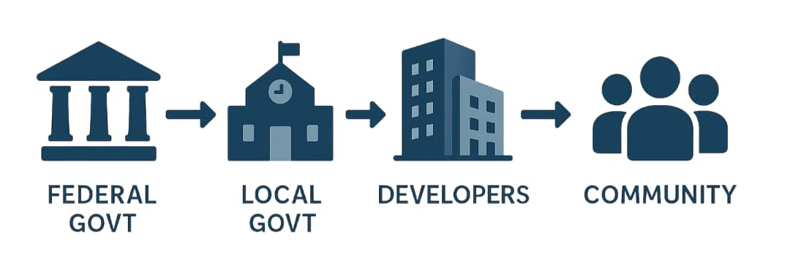
Federal support should encourage local governments to collaborate with builders who commit to affordability. This accelerates production of workforce housing without increasing taxes.
7. Incentivize Long-Term Affordability and Small-Scale Development
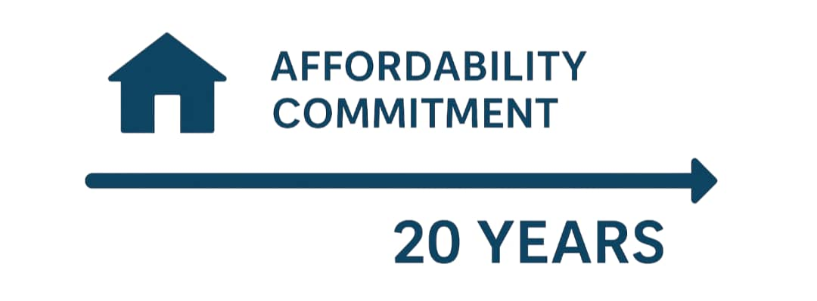
- Twenty-year affordability covenants
- Tax incentives for landlords who keep rents stable
- Grants for duplexes, triplexes, and accessory dwelling units
These strategies create supply at multiple scales while protecting affordability.

VI. ECONOMIC AND SOCIAL IMPACT
____________________________________________________________
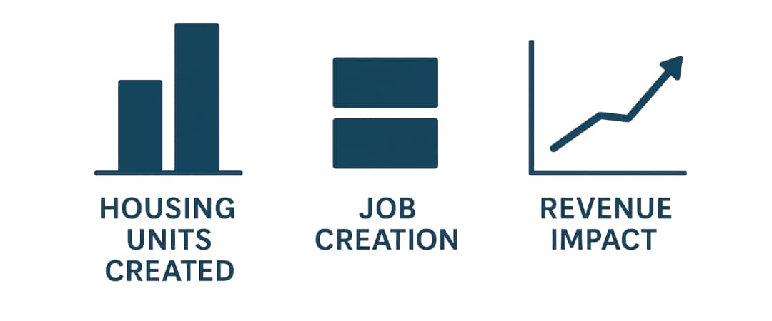
A. Projected Housing Units Created | B. Job Creation | C. Revenue Impact
- 12,000–18,000 new units across Broward and Palm Beach in 10 years. | - 8,000 construction jobs  - 6,000 service, retail, and support jobs | - Increased consumer spending from senior tax relief  - Redevelopment boosts local tax base over time  - More stable workforce supports local economic growth
VII. WHY THESE SOLUTIONS WORK
____________________________________________________________
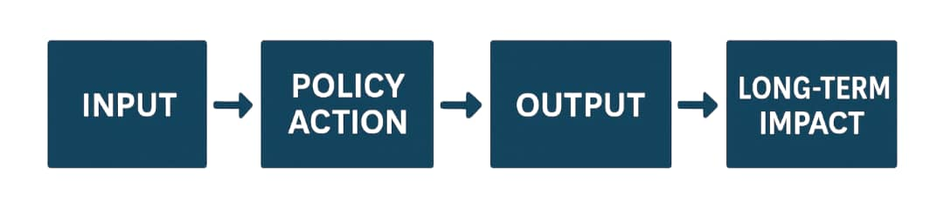
These policies succeed because they take a balanced approach.
- They increase supply while reducing cost. Tackling the market from both ends rather than from one angle.
- They protect seniors and disabled residents. Tax-relief pillar gives dignity and stability to the people most at risk.
- They strengthen the workforce. Affordable homes keep essential workers in the communities they serve.
- They rely on proven models. Port St. Lucie shows how local innovation can scale region-wide.
- They combine federal direction with local execution. Bringing leadership where it’s needed and empower cities to act quickly.

VIII. CONCLUSION
__________________________________________________________
South Florida is approaching a historic tipping point. Families can’t build stable lives when housing costs rise faster than wages. Seniors can’t age with dignity when taxes, insurance, and utilities outpace their fixed incomes. Workers can’t sustain the economy when they can’t live near the jobs that rely on them.
This white paper offers a clear, compassionate, and economically responsible path forward. At its heart is the elimination of property taxes for seniors 65+ and disabled residents on fixed incomes. This policy, combined with targeted development strategies and federal-local coordination, creates a stronger foundation for affordability, equity, and long-term growth. Through these solutions, District 20 can lead South Florida into a new era of stable, attainable housing for all.

